ASSIGNMENT-1

Q.1 what is software? what is software engineering?

Ans. Software is a set of instruction or data used to operate computer and execute tasks.

Software engineering is a systematic approach to designing, developing, testing and maintaining software.

Q.2 explain types of software

Ans.

System software: System software is a program designed to run a computer’s hardware and applications and manage resources.

Middleware software: Middleware software is software that lies between an operating system and the application running on it.

Application software: Application software is programs user directly interact with for task like word processing, browsing, gaming, etc.

Programming software: Programming software are tools used by developers to write, debug, and manage code for creating application and software programs.

Driver software: Driver software enables communication between the operating system and hardware device.

Embedded software: embedded software controls hardware within devices, operating with minimal user interaction and often in real time.

Q.3 what is SDLC? Explain each phase of SDLC

The Software Development Life Cycle is a structured process used by software development teams to design, develop, test, and deploy software

**1. Planning**

In this phase decide what the project should achieve and how it will be done and make sure the project is possible and worth doing.

**2. Analysis**

In this phase team talk to users and gather detailed information about what they need and

They make sure all the requirements are clear and complete.

**3. Design**

In this phase team plan the overall structure of the system and how the parts will fit together.

**4. Development**

In this phase team write the actual code to create the software and test small pieces of the code to make sure they work correctly.

**5. Testing**

In this phase team check how the different parts work together.

Test the whole system to ensure it meets the requirements

**6. Deployment**

In this phase team and user plan how to release the software to the users.

Make the software available for use in the real world.

**7. Maintenance**

Fix any problems that come up after the software is released.

Keep an eye on the software to ensure it continues to run smoothly.

Q.4 what is DFD? Create a DFD diagram on flipkart

Data Flow Diagram is a visual representation that shows how data moves through a system. It uses symbols to illustrate processes, data flow paths, and storage locations, helping to understand and document system interactions and data movement.

DFD diagram on flipkart

DFD-0

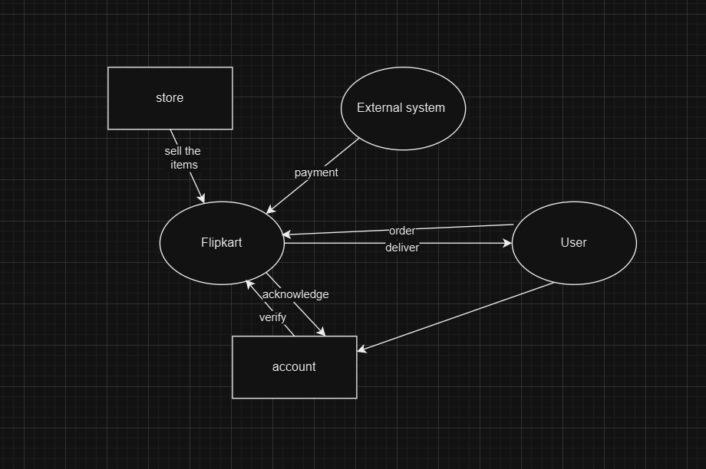

DFD-1

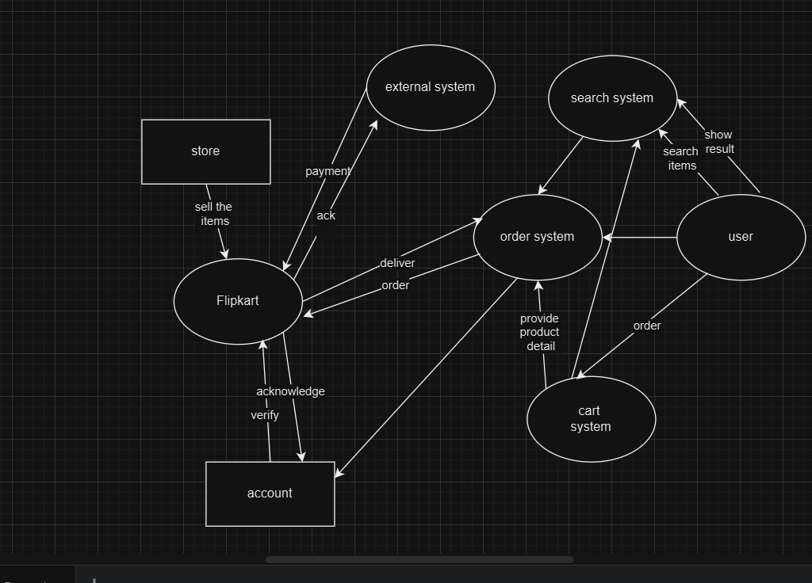

DFD-2

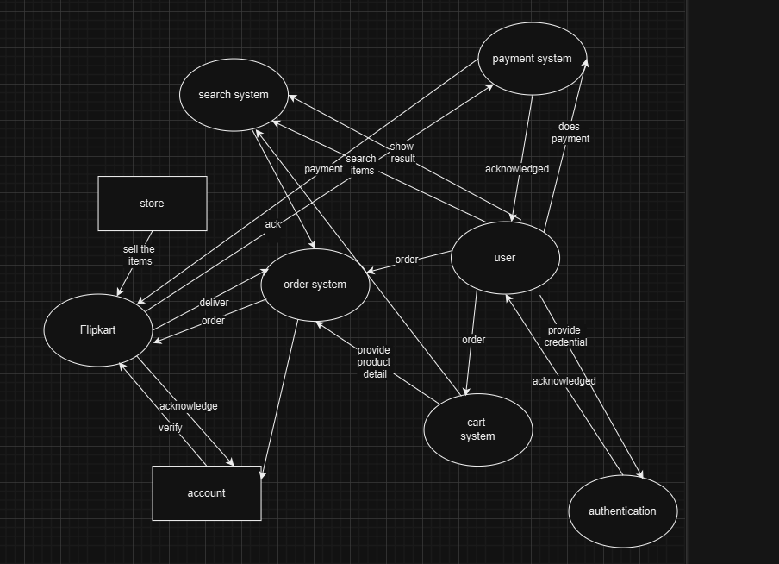

Q.5 what is flow chart? Create a flowchart to make addition of two numbers

A flowchart is a visual diagram that uses symbols and arrows to show the sequence of steps or decisions in a process. It helps to illustrate how something works or how to solve a problem in a clear and organized way.

Flow chart to make addition of two numbers

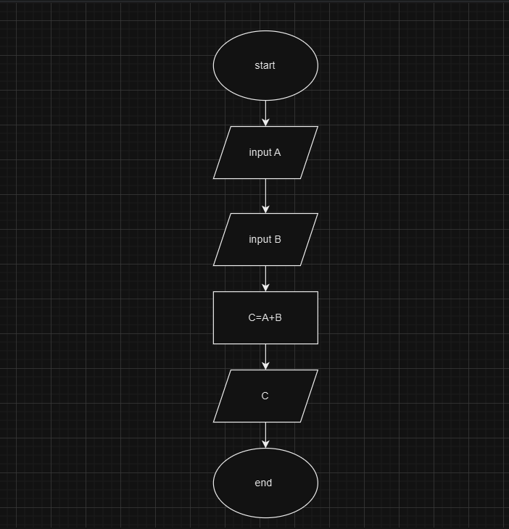

Q.6 what is use case diagram? Create a use case on bill payment on paytm

A use case diagram is a simple visual representation that shows how users interact with a system. It uses actors and use cases to illustrate these interactions and functionalities.

Use case on bill payment on paytm